Simple python code for Linear Regression model

import numpy as np
import matplotlib.pyplot as plt

# Sample data
x = np.array([1, 2, 3, 4, 5])
y = np.array([2, 4, 5, 4, 5])

# Calculate means
x_mean = np.mean(x)
y_mean = np.mean(y)

# Calculate the coefficients (slope and intercept)
numerator = np.sum((x - x_mean) * (y - y_mean))
denominator = np.sum((x - x_mean) ** 2)
slope = numerator / denominator
intercept = y_mean - slope * x_mean

# Prediction function
def predict(x):
return slope * x + intercept

# Generate predicted values
y_pred = predict(x)

# Plot the data and the regression line
plt.scatter(x, y, color='blue', label='Data points')
plt.plot(x, y_pred, color='red', label='Regression line')
plt.xlabel('x')
plt.ylabel('y')
plt.title('Simple Linear Regression (No sklearn)')
plt.legend()
plt.grid(True)
plt.show()

# Print the model
print(f"Slope: {slope}")
Print(“intercept:{intercept}”)
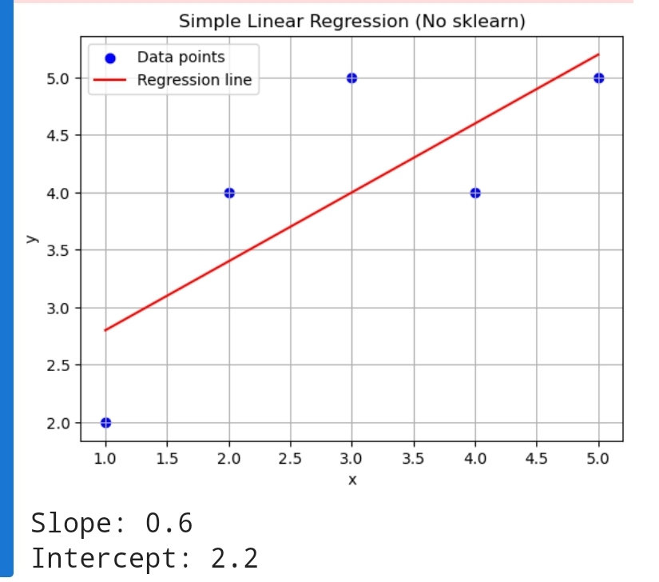

output:

